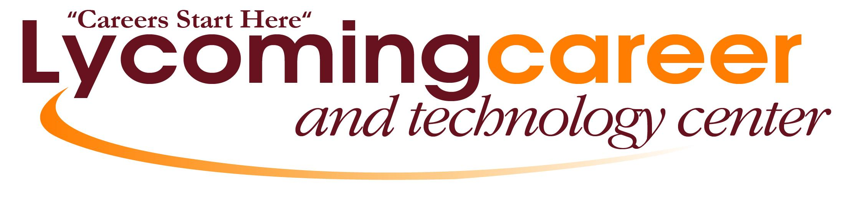

Course Descriptions

2024-2025

PROGRAM OFFERINGS
Automotive Technology

Construction Technology

Culinary Arts

Computer Systems Technology

Criminal Justice (Law Enforcement)

Early Childhood Education

Health Careers

SPECIAL PROGRAMS
Cooperative Education
College Credit Options

AUTOMOTIVE TECHNOLOGY – (2.0 hours/day)
If you are interested in cars and want to repair high tech vehicles, take a closer look at the Auto Tech program. This program, designed for students who would like to work in the automotive service industry, is certified by Automotive Service Excellence (ASE.) The LycoCTC Automotive Technology Program follows the National Automotive Technicians Education Foundation (NATEF) guidelines.
When you enroll in the program, you will learn about performance, computer electronics, engine and chassis diagnoses and repair. Through this program students may acquire a Pennsylvania Automotive State Inspection License, prepare for the Automotive Service Excellence (ASE) Certification, and complete SNAP-ON DVOM Training.
COMPUTER SYSTEMS TECHNOLOGY – (2.0 hours/day)
As a CST student you’ll dive deep into the fascinating realms of computer hardware, network technology, cybersecurity, and programming. You'll get your hands dirty building and repairing computers, setting up and securing networks, writing code, and protecting digital landscapes. But that's not all! We're not just teaching tech; we're empowering you for the future. This program offers you the opportunity to earn valuable CompTIA certifications like A+, Network+, Security+, and IT Fundamentals. These certifications will open doors to a wide range of career opportunities in IT. So, let's embark on this incredible learning adventure together, where we'll equip you with the skills and knowledge needed to thrive in the dynamic tech world. Get ready to shape your future in technology with us!
CONSTRUCTION TECHNOLOGY – (2.0 hours/day)
This program provides students the opportunity to learn skills in the construction field such as: carpentry, masonry, electricity, plumbing, heating, and air conditioning. Students learn safety practices as they relate to using hand tools, power tools and performing tasks in the construction industry. All students learn to use hand tools, power tools and the safety practices related to their use.
CRIMINAL JUSTICE – (2.0 hours/day)
The Criminal Justice program is available to high school students who are interested in law enforcement or the military. Through a combination of academic-based instruction and “hands-on” experience, students will acquire the basic skills needed to succeed in a related career field. Some of the areas studied include the criminal justice system, use of force, communication and report writing, patrol functions, crimes code and vehicle code, crime scene investigation, and physical education.
The Criminal Justice program helps to prepare you for a career in private security, law enforcement, corrections, military, or to continue your post-high school education.
CULINARY ARTS – (2.0 hours/day)
Did you ever wonder what it would be like being a chef working in a 5-star restaurant? What about being an executive chef working for a Food Service Corporation? Our program prepares you for higher education and gets you ready to attain your goals you have set for yourself. Our instructor will give you a jump-start on your career goals and help you receive your ServSafe certification.
EARLY CHILDHOOD EDUCATION – (2.0 hours/day)
This program prepares students for employment in early childhood education and childcare services and provides the foundations for study in higher education that lead to early childhood educators and child related careers. The course of study includes but is not limited to: planning and guiding developmentally appropriate activities for young children; developmentally appropriate practices of guidance and discipline; application of basic health and safety principles when working with young children; overview of management and operation of licensed child care facilities and employability skills.
This course emphasizes learning experiences, which will help students gain knowledge and understanding of the intellectual, physical, social, and emotional development of children from conception to adolescence. The students will have opportunities to apply their understanding about children through participation, observation of children individually and in groups, and planning and evaluating group activities, which meet their needs. It includes instruction in child development and behavior, as well as observations and participation in an actual on-site preschool.
This course provides a solid base for students planning to enter the fields of Occupational Child Care, Para-educator, or Elementary Education. This program is located at the Ashkar Elementary School in Hughesville.
HEALTH CAREERS – (2.0 hours/day)
As the world of medicine and science changes and grows virtually every day, the number of jobs in the health field grows as well. Join the Health Careers program and learn about the exciting world of healthcare in a productive hands-on learning environment to gain a valuable head-start in the healthcare industry.

The Health Careers Program offers students the opportunity to prepare for a variety of health occupations. Students will learn about human anatomy, common medical conditions, growth, and development,
medical abbreviations and terminology, and basic patient assessment and caregiving skills. Whether you are college bound or seeking employment immediately upon high school graduation, this program will prepare you for a future in the health field. Completion of the Health Careers program is not just educational; the program leads students to rewarding careers in one of today’s fastest growing job markets.

SPECIAL PROGRAMS
CAPSTONE COOPERATIVE EDUCATION
This senior student opportunity allows eligible students to get on the job training at a co-op or internship placement directly related to their program of study at Lycoming CTC. Students must have their program instructor’s recommendation to participate in this program.
COLLEGE CREDIT OPTIONS
Students interested in earning college credits while in high school have two options available through an agreement between LycoCTC and the Pennsylvania College of Technology:
- Attend Penn College courses on campus.
- Penn College Dual Enrollment Program. These courses are taught by LycoCTC staff during regular class time following the Penn College curriculum/syllabus.

To participate in either option, students must be recommended by their instructor and pass all applicable Pennsylvania College of Technology entrance requirements. Course options/availability vary from year to year, and may not be available to all grade levels.

All LycoCTC classes are aligned with the Pennsylvania Department of Education’s Programs of Study (POS) which are state approved career and technical education programs that credit skills and tasks learned in a CTC to a postsecondary degree, diploma or certificate; or an industry recognized certification. Through PDE’s SOAR program, students can move from high school to college and from college to a high-demand occupation by earning college credit while still in high school.

The Lycoming Career and Technology Center does not discriminate
on the basis of race, color, national origin, sex, disability or age in its programs or activities.

For more information or to arrange a visit, please contact:
Mr. Nathan C. Minium, Executive Director
293 Cemetery Street
Hughesville, PA 17737-1020
570-584-2300
www.lycoctc.org

